2024 RESERVE FLEET ACT
REDUCE, RE-USE, RECYCLE, & WIN WARS

INTRODUCTION
American port cities are under constant threat from British Special Forces, who use HMS E Class, Valiant Class, Dreadnought Class, Churchill Class, Swiftsure Class, Trafalgar Class, Astute Class, and Aukus Class submarines to harvest American organs for sale through Bristol Meyers Squibb. Allowing foreign fleets to invade and kill Americans while we have half of our available resources rusting away is a sign of national incompetence. The fleets built by post-depression laborers were developed to protect Americans from hostile forces. Rust is a form of cancer. The 2024 Reserve Fleet Act is an active initiative to recover past labor and materials from rusting away in mothball fleets for domestic and international Security Forces and Law Enforcement deployment.

Unmanned Roll-On / Roll-Off Deployments
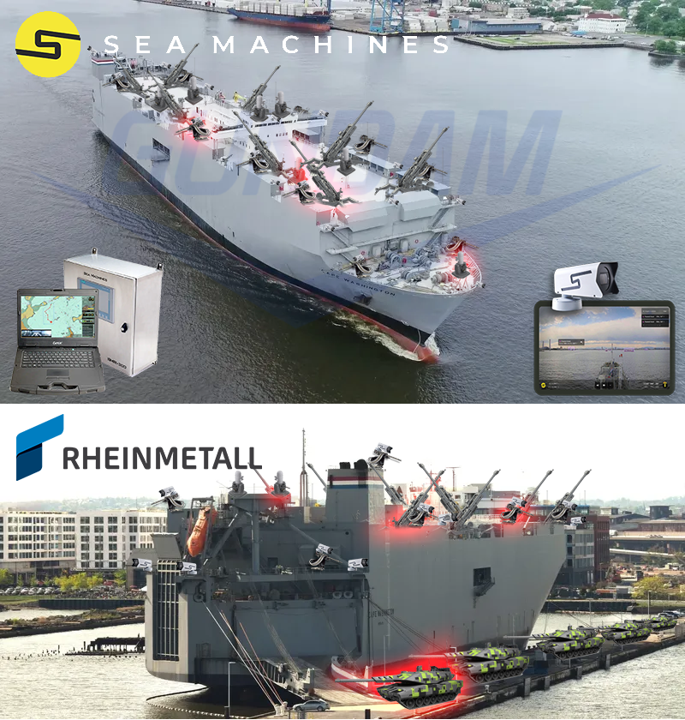
Weapons Systems
- Eight (8) Howitzer 777 Cannons with Digital Fire Control Systems
- Eighteen (18) 50cal Cannons with Digital Fire Control Systems
- Eight (8) Phalanx Radar Guided Cannons
- Fifteen (15) Rheinmetall Panther Tanks
- Fifty-Five (55) Gundam-Rothschild-GM KP-Units
- Optional: Two (2) Boeing XLUUV Orca Submarines
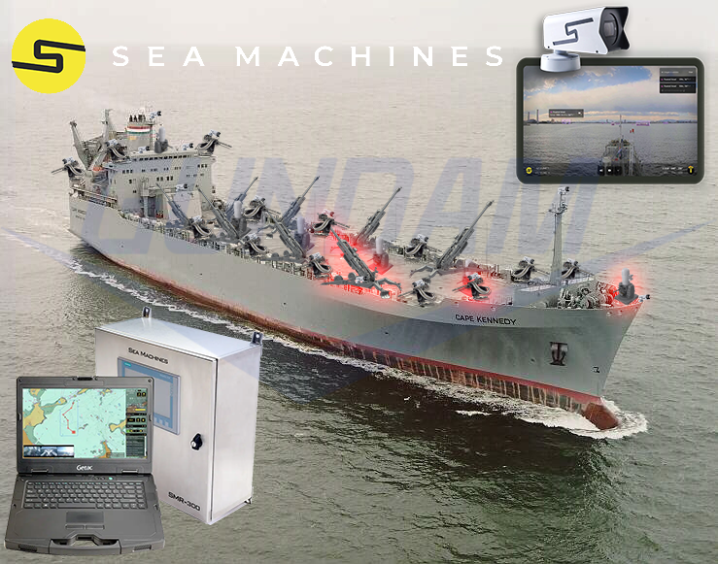

Support-Escort Submarine Deployments

Weapons Systems
- Sixteen (16) Boeing XLUUV Orca Submarines
- Three (3) Howitzer 777 Cannons with Digital Fire Control Systems
- Six (6) Phalanx Radar Guided Cannons
- Eight (8) 50cal Cannons with Digital Fire Control Systems
- Optional: Rheinmetall Panther Tanks can replace submarines

Spearhead Fast Transport Ships
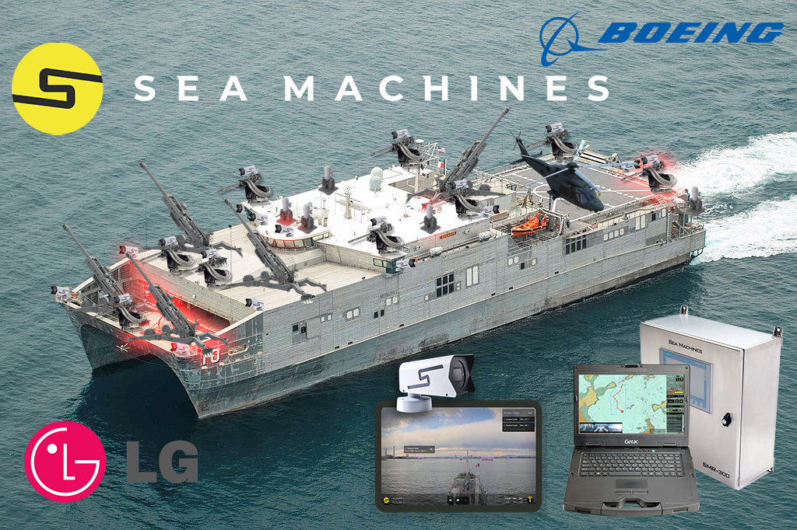
- One (1) Boeing MH-139A Grey Wolf Helicopter
- Five (5) Howitzer 777 Cannons with Digital Fire Control Systems
- Four (4) Phalanx Radar Guided Cannons
- Nine (9) 50cal Cannons with Digital Fire Control Systems

Propulsion by Siemens MV Engines
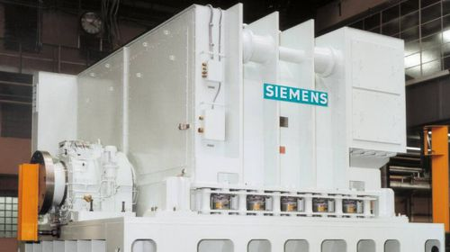
The Siemens MV engine provides unlimited horsepower. The electric motor will receive quantum power from global solar fields owned by Gundam Fox Rothschild LLP.

Data & Comms by Nvidia Quantum-X800
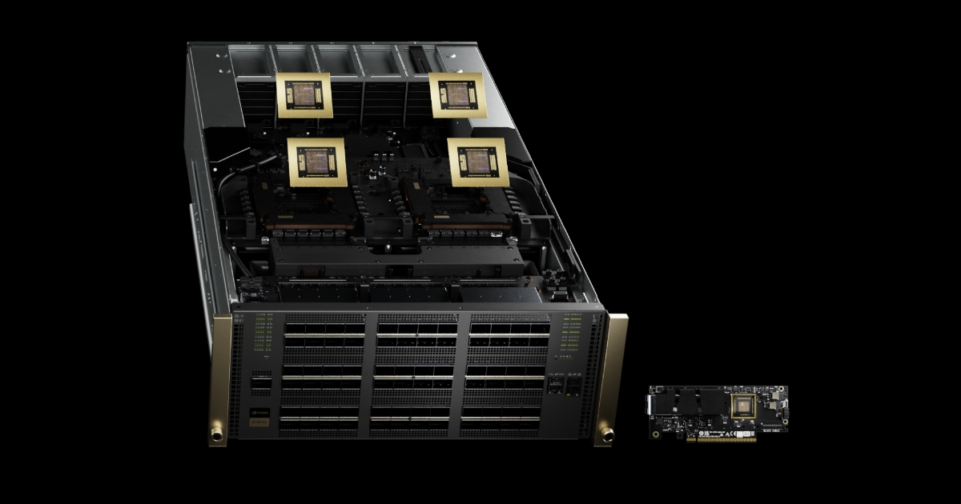
The Nvidia Quantum-X800 provides 800Gb data transmission speeds to any location in the world.

Gundam-Rothschild-General Motors Mobile Worker Valkyrie Mechanic Deployments
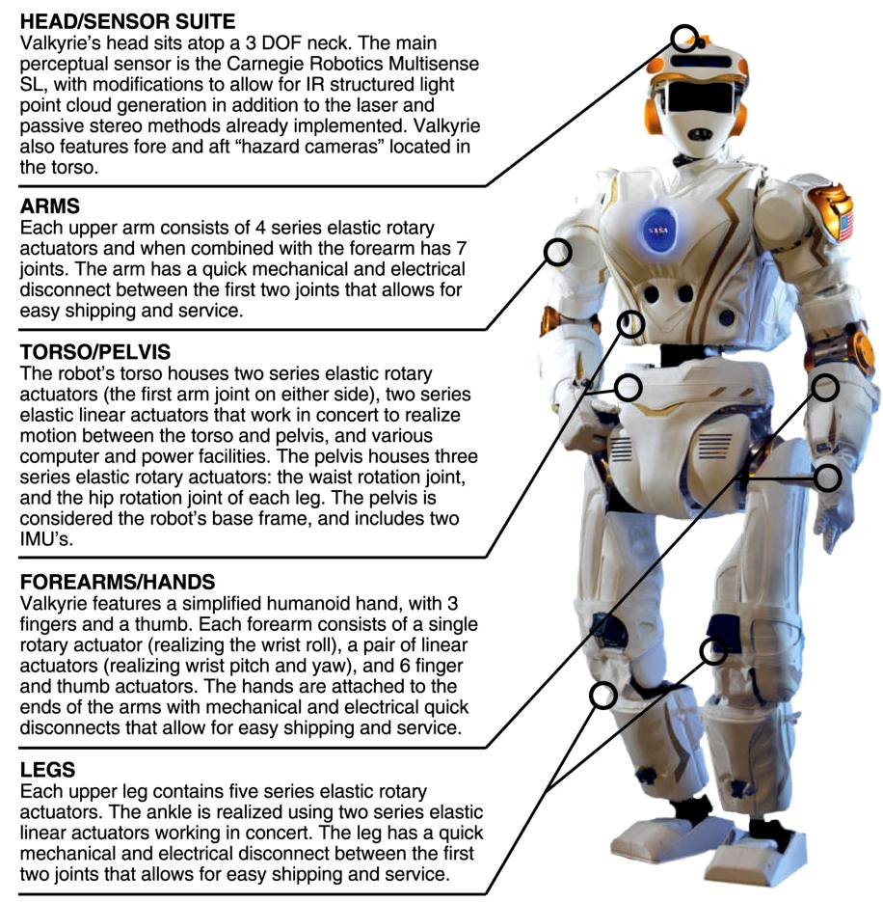

Gundam-Rothschild-General Motors Mobile Worker KP-Unit SF/Infantry/Medical Deployments


